Greenwood art Gallery
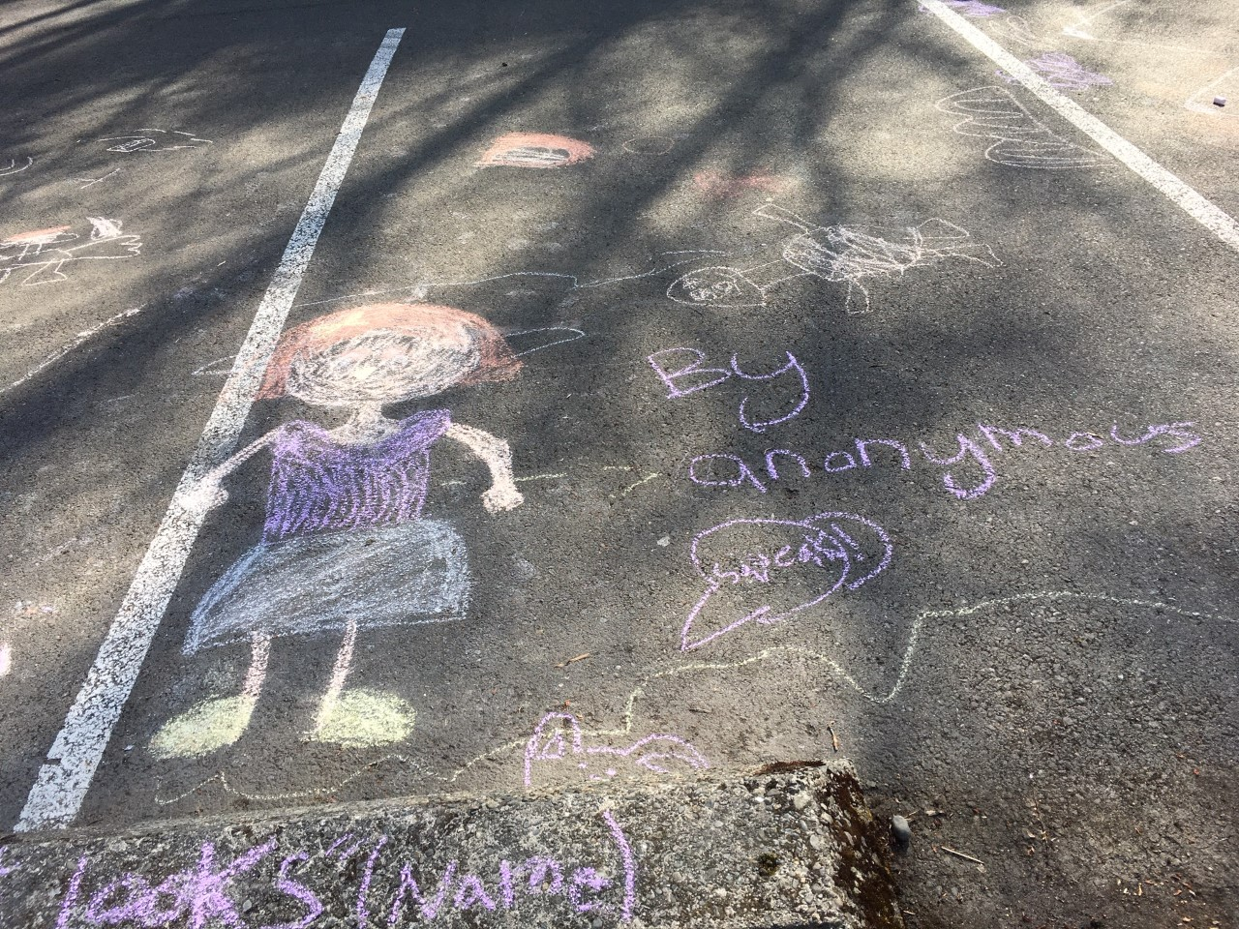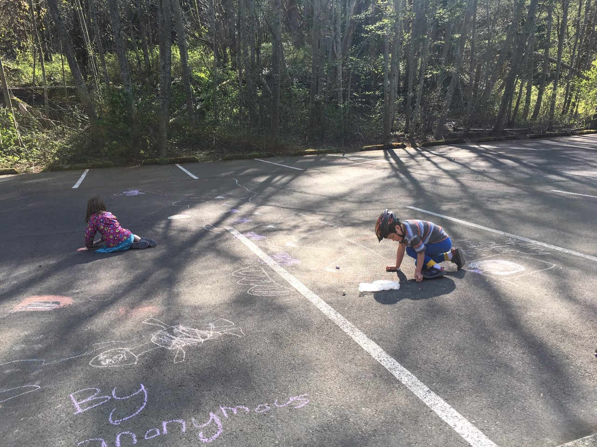
Chalk Art Ella and William

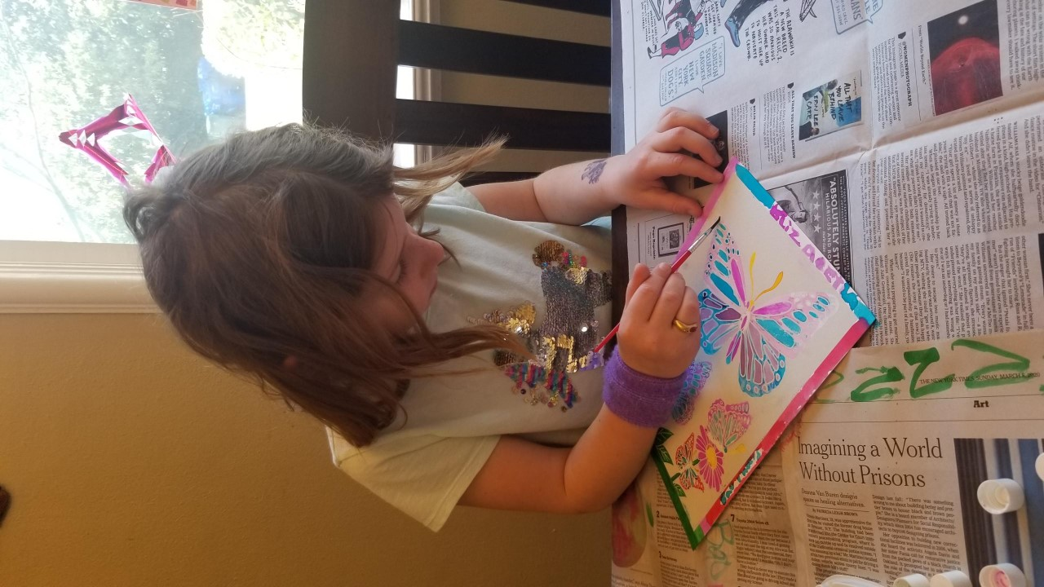 Elizabeth G.

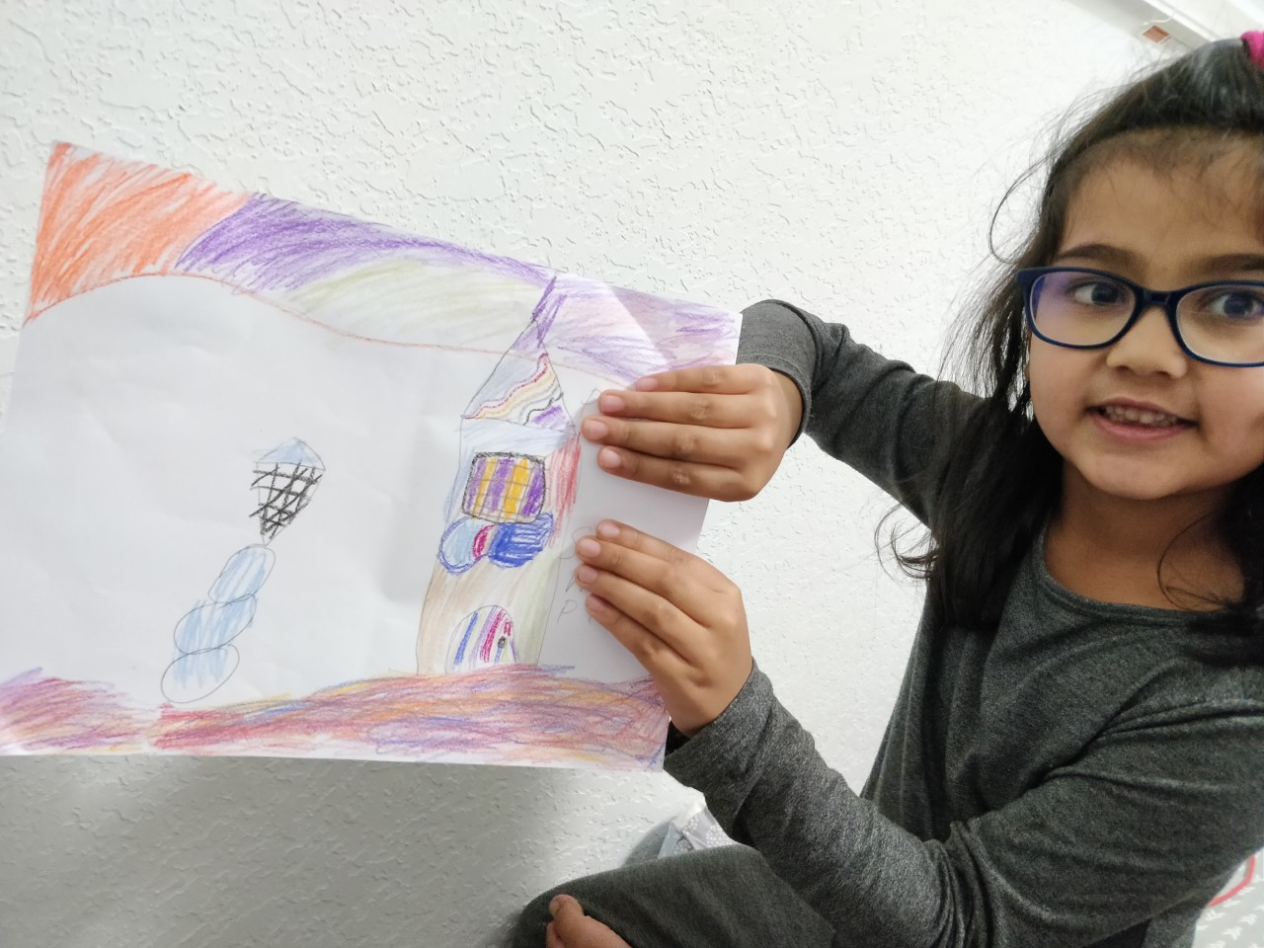 Sara 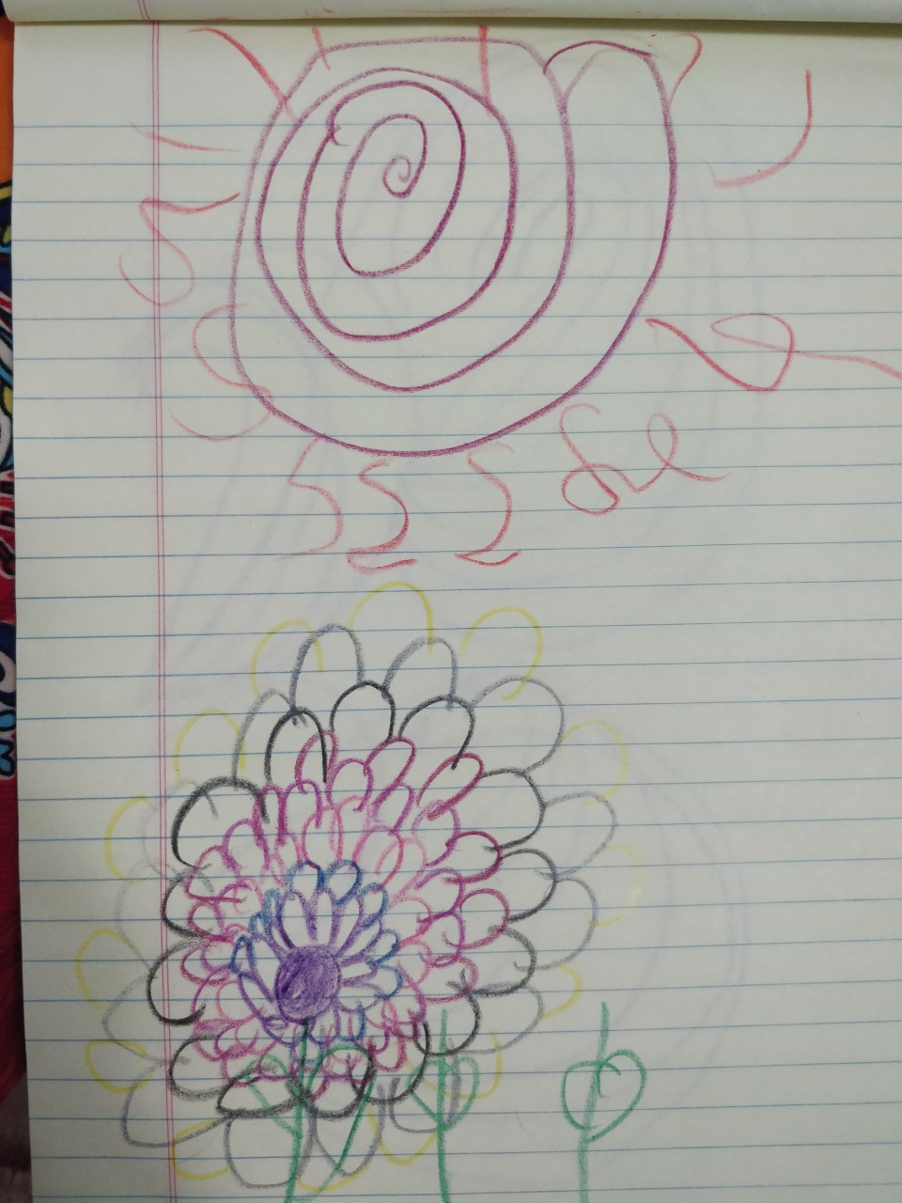

Artwork done this year…
K-1st Grade Classes

The Robot and the Bluebird
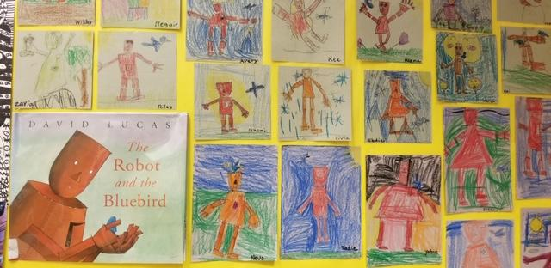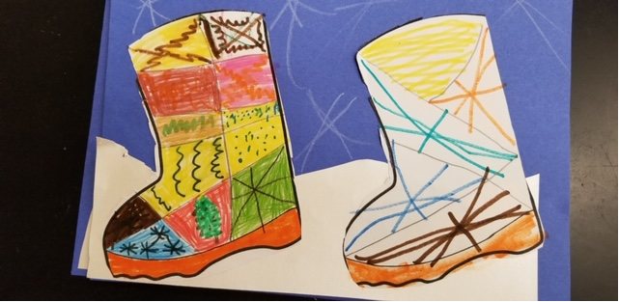
Wild Snow boots
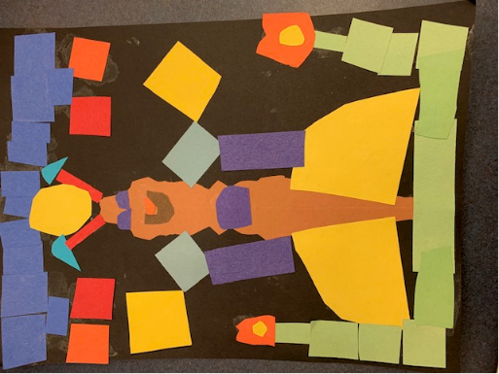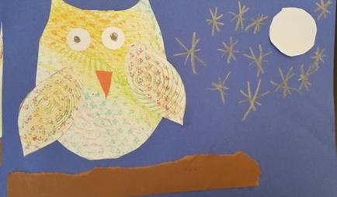
Symmetrical Bug Collage Crazy Owl

2nd-3rd Grade Classes

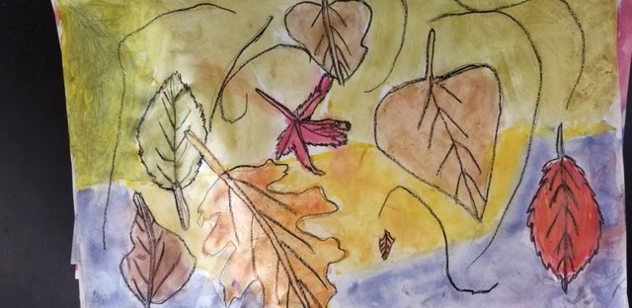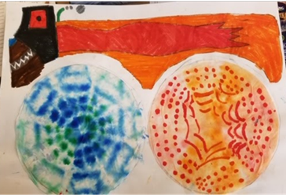
Observational drawing-fall leaves Monster Truck
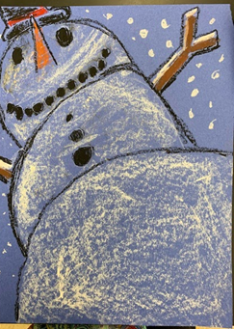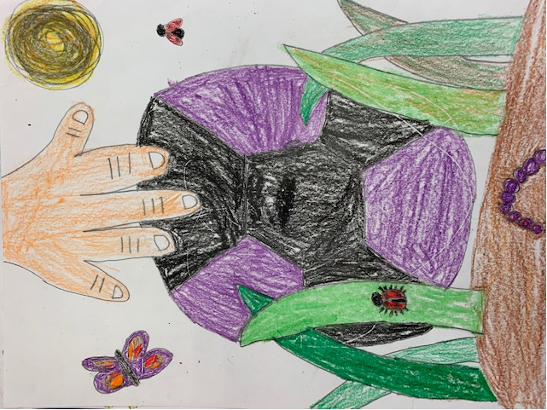
“Worm’s Eye View” Snowman A Bug’s Perspective…

K-3rd grades:
EVERYONE BELONGS EVERYONE IS WELCOME HERE
K- 3rd Grades Celebrate Diversity through art. The figures are shown connecting and supporting each other. Although each figure is the same size and shape, all are created with different patterns and colors. We are the same but different, all belong and are welcome.
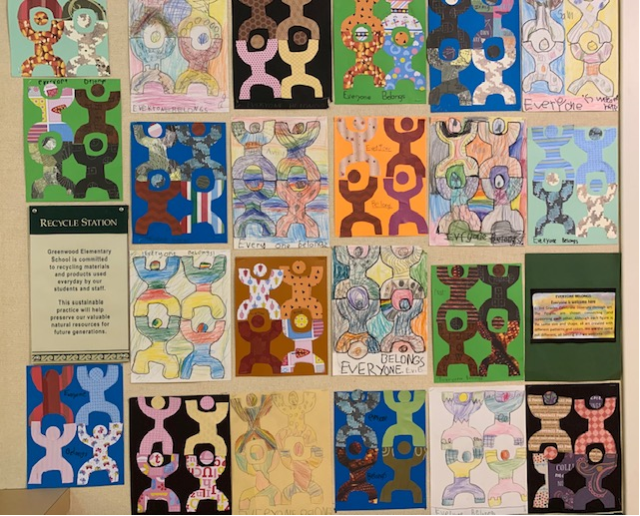
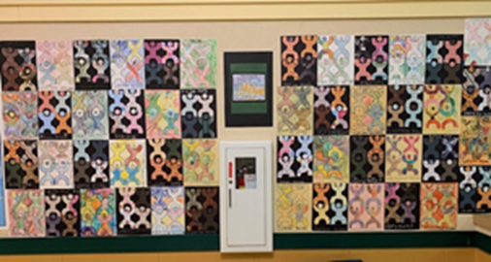
4th/5th Grades

Pumpkins Inspired by Yayoi Kusama
Students made contour drawings (organic shapes) from real pumpkins brought to the classroom. They then chose either an analogous or a complementary color scheme. To create unique colors, they mixed tempera paint to make tints or shades to paint their pumpkin and background based on their plan. A geometric grid was drawn with a sharpie over the painted background to create a dynamic contrast.

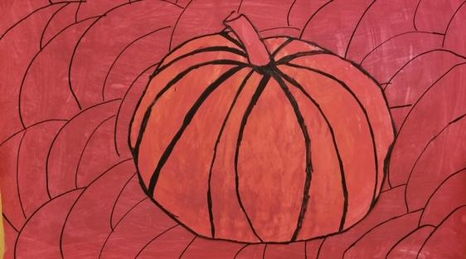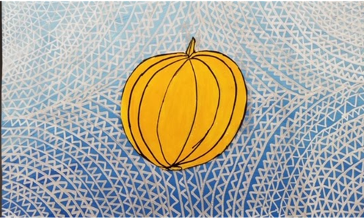
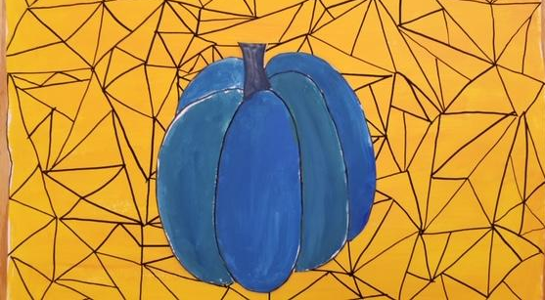

MANDALAS
Radial Symmetry
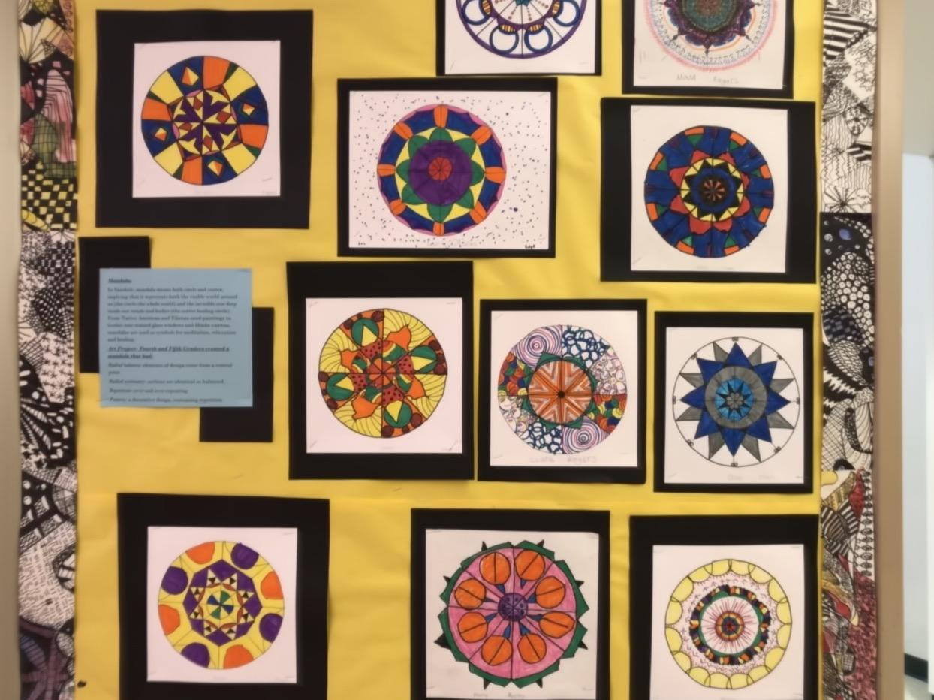

“Thanks Cubes”-
Inspired by Los Angeles street artist Thank You X.

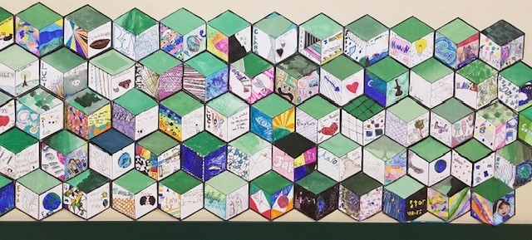

MARTIN LUTHER KING PHOTO TRACING
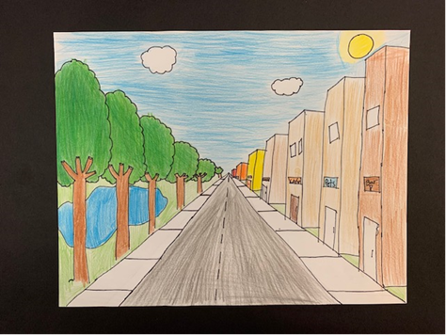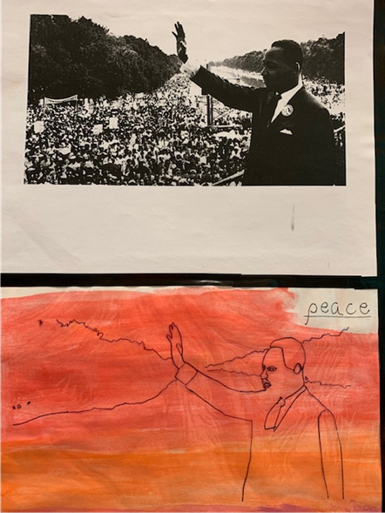
CITYSCAPE ONE POINT LINEAR PERSPECTIVE

Ms. Wilburn’s Art- I thought it would be fun to share a piece of my work too…
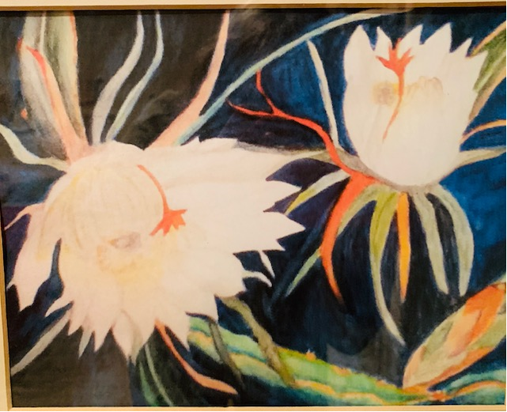 Cereus Cactus: watercolor

